This is the code for Ming’s paper: doi: https://doi.org/10.1101/2019.12.14.876201

The code uses CaImAn to analyze GCaMP dF/F imaging data.

**Ming’s software**

**Motion correction**

Ming uses TurboReg, a plugin for ImageJ for the motion correction.

<http://akiramuto.net/archives/208>

**CalmAn**

We then use CaImAn to find ROIs. Please set the MATLAB path to CaImAn because some routines are used by drgCaImAn_script

<https://github.com/flatironinstitute/CaImAn-MATLAB>

**Olfactometer/readdropcspm_hf**

This program is used to generate the percent correct vs trial plots. The input is from spm.mat files

**CaImAnDR/drgCalmAn_script.** Finds components (ROIs) using CaImAn code. It ouputs a file called file_name_CalmAn.mat. It is important to enter the CaImAn parameters using options = CNMFSetParms(…)

**CaImAnDR /drgCalmAn_dropc.** This routine takes the output from drgCalmAn_script (file_name_CalmAn.mat), the lick recordings from the INTAN board (.rhd format) and metadata from dropcspm_hf.m to generate average deltaF/F and lick traces.

The output is saved in a file with the suffix _pre_per.mat

The output can be used for perceptron analysis, etc.

**CaImAnDR/drgCaImAn_batch_dropc**. This does a batch of warping and drgCalmAn_dropc. If you want warping enter

do_warp=1;

If you do not want to warp

do_warp=0;

You need to have a file called:

drgCaImAn_dropc_choices_some_name.m

that has all the files to be processed.

**CaImAnDR /drgCaImAn_dropc_correlation.** This routine takes the output from drgCalmAn_script (file_name_CalmAn.mat), the lick recordings from the INTAN board (.rhd format) and metadata from dropcspm_hf.m to calculate correlation (and covariance) of Ca traces between components. The covariance is an input to for simulations.

**CaImAnDR /drgCaImAn_average_betweenSession_dFF** averages the data between different sessions. It needs the output file generated by drgCaImAnBatchPerSession

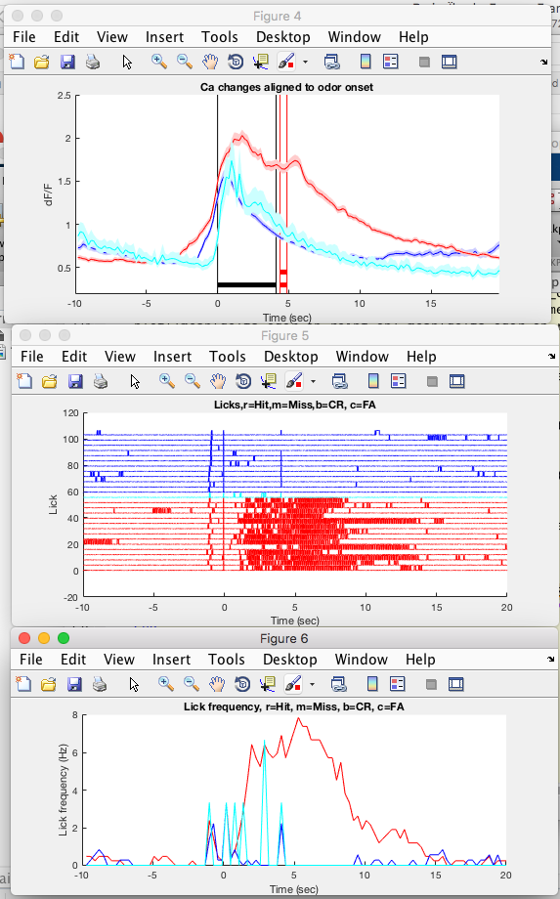

**CaImAnDR /drgCaImAnBatchPerSession.** This routine takes input from a file named drgCaImAnChoices_name of the file.m

It uses the output of drgCaImAn_dropc to perform whole session analysis. Make sure to list the files in the Choices file in order of acquisition.

It generates:

**CaImAnDR /drgCaImAnBatchPerSessionReversal.** This is used for the reversal figure. This routine takes input from a file named drgCaImAnChoices_name of the file.m

It uses the output of drgCaImAn_dropc to perform whole session analysis. Make sure to list the files in the Choices file in order of acquisition.

This code accepts multiple sessions

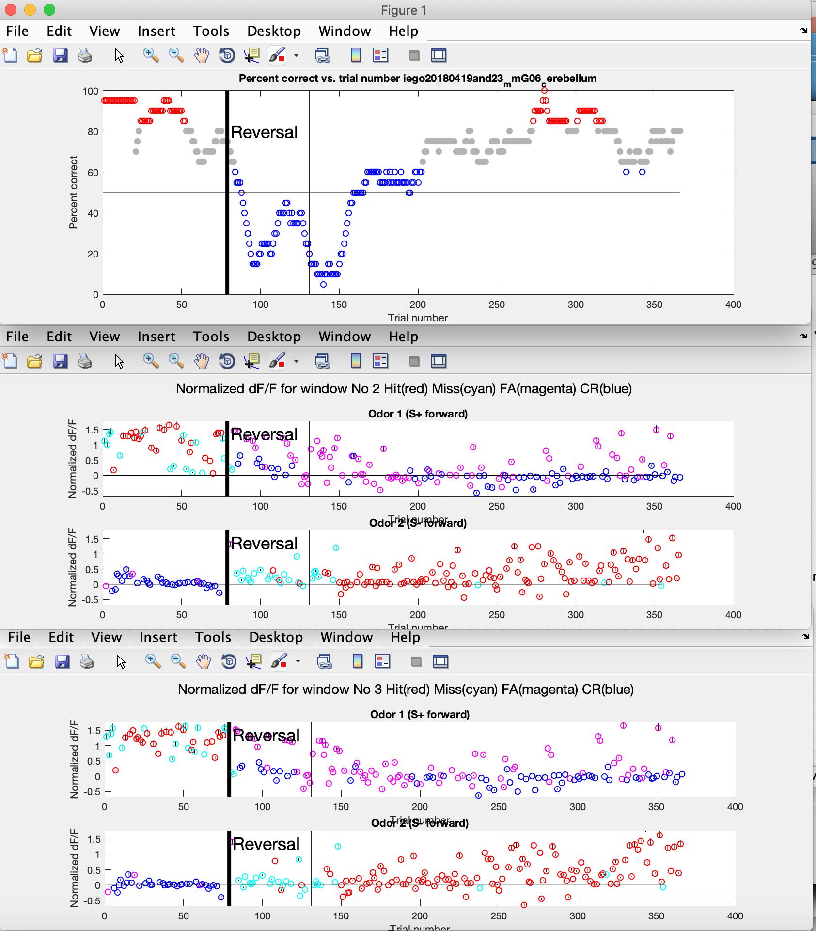

**CaImAnDR/drgOpticalFlowEstimate.** Optical Flow Estimation Using the Farneback Algorithm

The input is the .mp4 movie. Saves _optflow.mat

**CaImAnDR/drgOpticalFlowEstimateBatch**

Batch optical flow estimation for multiple files using the Farneback algorithm. This code needs a choices file containing the names of the .mp4 input files (like drgOptFlowChoices20180419_mmG06_cerebellum.mat). The output is one _optflow.mat file for each input file.

**CaImAnDR/drgOpticalFlowAligned.** Alignment of Optical Flow Estimation with the deltaF/F

The inputs are the pre_per.mat generated by drgCalmAn_dropc_plot and optflow.mat generated by drgOpticalFlowEstimate.

**CaImAnDR/drgAlignOpticalFlow.** Allows the user to find whether the alignment is correct.

**CaImAnDR/drgCaImAnBatchPerSessionEventsPerTriallickvsdFFOptFlow**. This code does a movement and lick derivative analysis per trial. The program needs a choices file such as drgCaImAnChoicesDiego20180910_mmPVG04_CerebellumLDAOpFlow

**CaImAnDR/drgCaImAnBatchPerSessionEventsPerTriallickvsdFFOptFlowDimensionality.** This code does a dimensionality analysis.

**CaImAnDR/drgCaImAn_glm.** This code does the glm analysis of a file generated by drgCaImAnBatchPerSessionEventsPerTriallickvsdFFOptFlow.m

**CaImAnDR/drgCaImAn_dropc_perceptron.** Performs perceptron analysis.

**CaImAnDR/drgCaImAn_rainbow**. Generates pseudocolor plots of the deltaF/F traces per ROI

**CaImAnDR/drgCaImAn_get_warped_components**. This function warps the ROIs of the reference tif to the other tif. It saves data appropriate for drgCalmAn_dropc

**CaImAnDR/drgCaImAn_average_betweenSession_dFF** averages the data between different

sessions. It needs the output file generated by drgCaImAnBatchPerSession

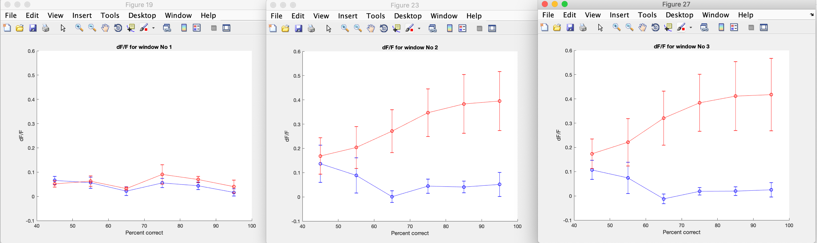

**drgCaImAnBatchPerSessionReversalPerTrial**

Needs a choices file such as drgCaImAnChoicesDiego20180910_mmPVG04_Cerebellum. Needs the output files from drgCaImAn_batch_dropc.m

**drgCaImAnBatchPerSessionReversalPerTrialLDA.** Generated the example of LDA timecourse in Ming’s Fig. 3. This example is generated with drgCaImAnChoicesDiego20180910_mmPVG04_CerebellumLDA

**drgCaImAnBatchPerSessionEventsPerTrialPCA**

Sorts the predicted responses for Hit, Miss, CR and FA and generates a PCA analysis plot. It needs as input the output files of drgCaImAn_batch_dropc and a choices file such as drgCaImAnChoicesDiego20180910_mmPVG04_CerebellumLDA defining the windows (3-4 sec, etc) and making sure the sessions do not include reversals.

**drgCaImAnBatchPerSessionEventsPerTrialLDA**

Sorts the predicted responses for Hit, Miss, CR and FA and generates the output file for lda_per_event_all_files.m. It needs as input the output files of drgCaImAn_batch_dropc and a choices file such as drgCaImAnChoicesDiego20180910_mmPVG04_CerebellumLDA defining the windows (3-4 sec, etc) and making sure the sessions do not include reversals.

**lda_per_event_all_files.m**

Generates LDAperevent.fig showing that the Ca changes during mistakes can predict the odor, with some very interesting exceptions. It needs input generated by drgCaImAnBatchPerSessionEventsPerTrialLDA

**drgCaImAnBatchPerSessionEventsPerTriallickvsdFF**

Does the analysis of the slope of lick frequency vs. slope of dFF (as in Gaffield 2017). It needs as input the output files of drgCaImAn_batch_dropc and a choices file such as drgCaImAnChoicesDiego20180910_mmPVG04_

**drgCaImAnPerTrialLDASubsampleSimulation**

This code simulates activity of multiple components with different covariant activity to analyze the dependence of LDA prediction on the number of components

**drgCaImAn_batch_dropc_no_microscope.m**

This is used to process files acquired in a session to study the changes

in behavior and licks when the MLIs are activated with optogenetics

Needs as an input the ouput files from the dropcspm_hf.m (.mat) and from

INTAN (.rhd)

Needs a dropc choices file such as

drgCaImAn_dropc_choices_PVhM4Di_04292019.m

or if you want to save time typing:

drgCaImAn_dropc_choices_PVhM4Di_all_files_04292019.m

**drgCaImAnBatchPerSessionLicks**

This code does a lick analysis for sessions where we record the behavior and licks

for optogenetic modulation of behavior/licks by turning MLIs with

optogenetics

Needs a choices file such as

drgCaImAnChoices_20190312_mmPVsoChR02_Cerebellum_licks.m

% Needs the output files from drgCaImAn_batch_dropc_no_microscope.m

**drgCaImAnBatchMultiSessionLicks**

drgCaImAn_multichoices_PVhM4Di_all_files_05052019

**drgCaImAnBatchPerSessionPerTrialLDASubsample**

This code does a linear discriminant analysis for spm data using subsets of components

Needs a choices file such as drgCaImAnChoicesDiego20180910_mmPVG04_Cerebellum

Needs the output files from drgCaImAn_batch_dropc.m

**Zoe Donaldson’s LDA demo**

This is a demo of our use of LDA

**LDA_demo** calls drgCaImAnLDAtimecourse.m to process data from Ming’s Figure 3C (MLI data.mat data available on request).

**drgCaImAnLDAtimecourse** performs LDA for MLI data.mat

**Connor McCoullough’s software**

**drgcmCaImAn_batch_dropc_rhd.m** reads the images, olfactometer file and rhd for Connor’s analysis. You need a choices file such as drgCaImAn_dropc_rhd_choices_157565_9_27CA.m

**drgcmPostHocLickReward.m** re-evaluates the scoring of the hits, CRs, etc.

drgcmCrossPCArhddFF takes as an input the *_batch_per_file.mat and outputs the correlations between LFP and dFF.

drgCaImAn_dropc_nsampler